Sharing Video to a Course Activity

Your instructor may ask you to share a video as a component of a course activity. You might contribute to a virtual gallery for your classmates to “walk through”, present a topic as part of a discussion, or demonstrate a concept to your instructor. Canvas offers multiple ways to do this and uses a partner video application called Kaltura. There are two video areas in Canvas—the Personal and Course Video Gallery. The Personal Video Gallery is your individual library and any files you add there are available to you when you log into Canvas. The Course Video Gallery is a course specific library and those files are available when you are in that course. Whenever you interact with the Canvas Course or Personal Video Gallery Kaltura is helping in the background.
In this handout review how to:

- Share a video to the Course Video Gallery.
- Add (embed) a video to a course discussion.
- Submit a video to an assignment.
- Sharing a Video to the Course Video Gallery

When you log into your course select the Course Video Gallery from the left navigation pane.
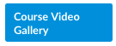
This brings you to the Media Gallery for this course. There may be videos already there uploaded by your instructor or classmates.

Upload your video by selecting Add Media.
This brings you to your entire personal video collection. You may see files you have added from previous courses and assignments.  Select Add New to upload your newly created video.  Select Media Upload from the Add New dropdown menu.  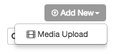 | 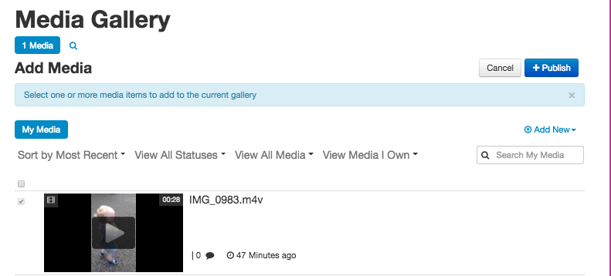
Select the Choose a file to upload button and navigate to the video file you want to add to the course gallery. Select it.

Your video will begin to upload. Note: depending upon the size of your video file the time it takes to completely upload will vary. The blue progress bar tells you how much of the file is uploaded and how much is left to go.  When the entire file is uploaded the blue progress bar turns green with a success message that reads Upload Completed. | 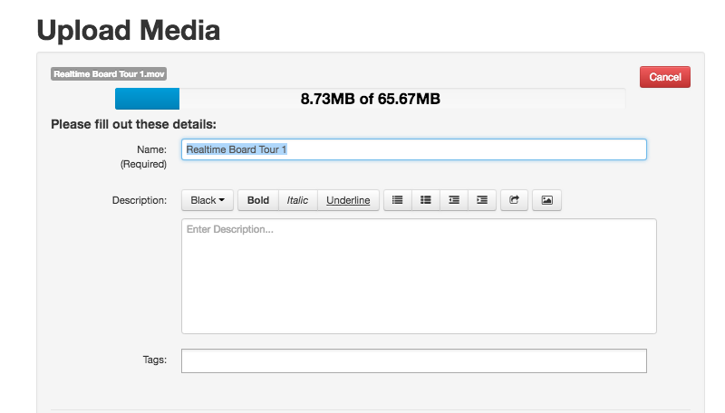
At this step you may add additional information like a description or tags before leaving the Upload Media area.  By successfully adding your video to the Course Gallery you have added your video file to your Personal Gallery at the same time.  Important Note: You will not see your uploaded video in the Course Media Gallery until your instructor has approved your submission. | 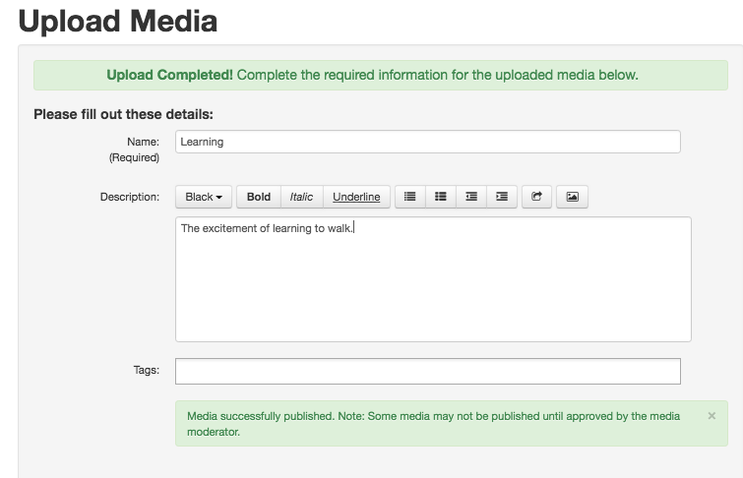
- Adding a Video to a Course Discussion

Note: using Your Media Gallery this way will embed your video file in your discussion post versus attaching it enabling viewers to play it without downloading it.

Navigate to the discussion thread where you will share your video presentation and begin to compose your Reply Post.

Select the colorful Kaltura icon from the HTML Editor.
This will bring you to your personal video library in Canvas.
Select the video file you want to add to your discussion post by using the corresponding blue select button. This will bring up a size selection drop down menu.  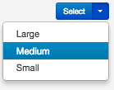  If you are adding a new video, follow the steps from the previous section “Sharing a Video in the Course Video Gallery” –but use your personal gallery. | 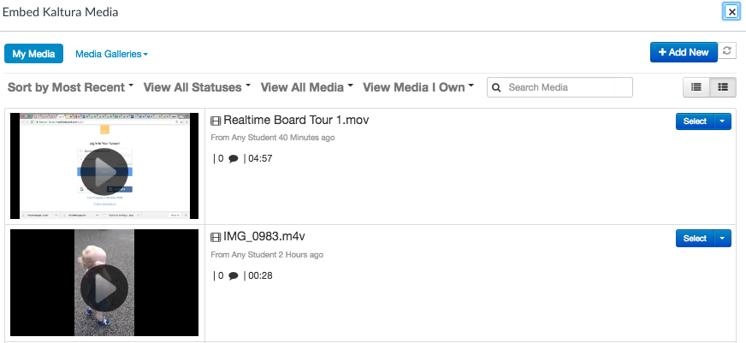
Your video is embedded in your response. Post your discussion reply and it will be available to everyone in the course to play without downloading it and opening it.  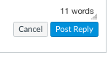 | 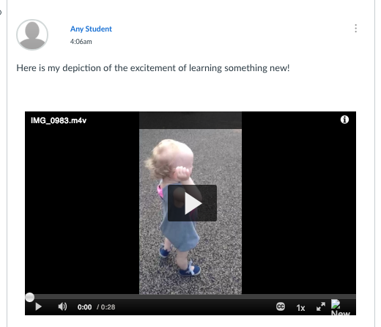
- Submitting a video to an assignment.  Your instructor can set up an assignment to receive an online video submission. This option allows you to create a media file or upload one you have already created. Select the Record / Upload Media button.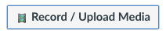 | 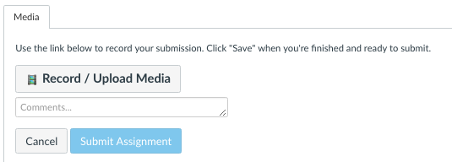
Select the Upload Media tab and Select Video File button.

Navigate to the video file you want to submit to the assignment.
When you video file is finished uploading select the Submit Assignment button.  You can review your submission by selecting the link Submission Details.  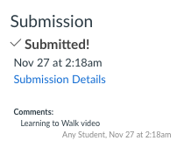 | 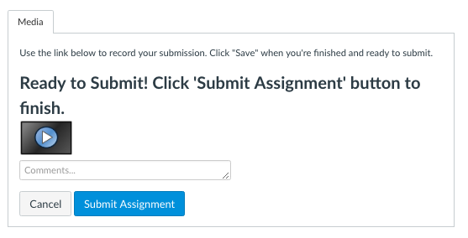
In the Review window you can play your video or resubmit your assignment. Note: this will delete your first submission. | 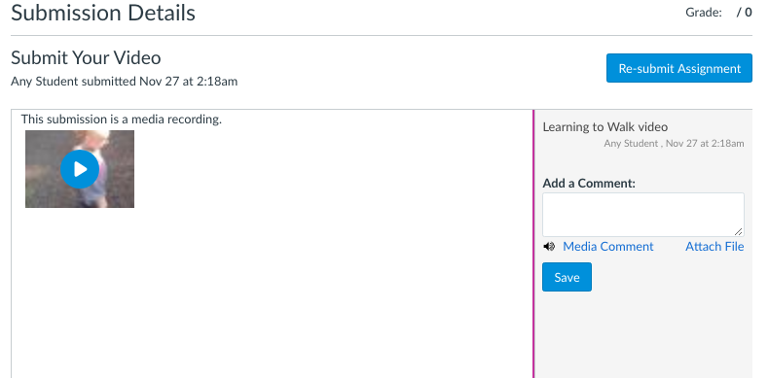

_{11/26/18}

